Name Social Studies, Ch.3 Ancient Israel

Date Section 2—PowerPoint Class Notes

**The Israelites Choose a King**

* 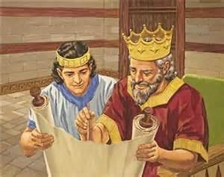Around 1000 BC the *_______________* were the strongest people in _____________, not the Israelites. The Philistines built _____________ cities and had __________weapons.
* The ______________ began to copy the Philistine’s ______________, so many Israelites thought a __________of their own would prevent this from happening.
* An Israelite king would also __________ their own tribes.

**The Rule of King Saul**

* Around 1020 BC Israelites asked ____________ (a judge and prophet) to choose a __________.
* Samuel chose ___________ a warrior-farmer.
* Saul defeated Israel’s _____________ but disobeyed some of God’s ____________________.
* 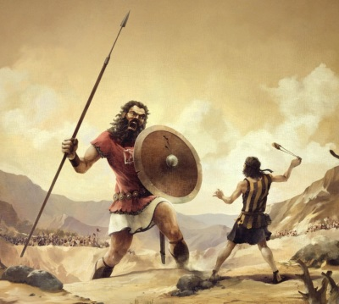God instructed Samuel to ______________ another king and anoint him in secret. His name was ______________.
* David was known for his _____________ and __________________. Before a _____________ with the ____________________, David fought a giant named ______________. With his _________________, David killed Goliath with a single smooth ______________.

**David and Solomon**

* David wasn’t able to become king until _____________, but once in power he drove the __________________ out of the area which allowed him to _____________________________ for the Israelites.
* Israelites remember ____________ as their _______________ king, as Jews do today.
* 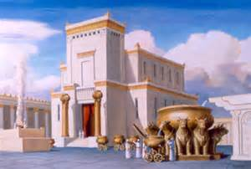When David ________, his son ______________ became king. Solomon finished building the famous ____________ in _____________________.
* Solomon’s temple became a ___________ and center of Jewish ___________. Many Israelites did not like Solomon because he ___________ them so much, to pay for his great _________________.
* Solomon was also known for his wise ____________, or __________________.
* Solomon made the Israelite men who couldn’t pay his _________________ to work in the _________ mines.
* This made Solomon very _________________.
* When Solomon died, the 12 __________ split up. ____ went to the ________ and formed the ________________________. 2 went _________ and formed the smaller ___________________________.

**Troubled Times**

* The _______________ of Israel and Judah felt threatened by their powerful neighbors, the _______________________________.

**Who Were the Prophets?**

* During the troubling times people who became known as the _____________ brought hope to the people. The Prophets taught people to live ______________.

**What Caused the Fall of Israel?**

* In 722 BC the _______________ conquered Israel and ________________ the 10 tribes. They became known as the ______________________ of Israel.

**What Caused the Fall of Judah?**

* In 620 BC the ________________ conquered Judah. Later still, the ________________conquered Egypt.
* _____________________________ treated the Jews harshly. The Jews planned a revolt, but it was stopped and _________________ was destroyed. The Jews were sent to ________________ in captivity. This time was known as the Babylonian Captivity.